Draft Annex to ISPM 27: Fusarium circinatum (2006-021)
Status box
This is not an official part of the standard and it will be modified by the IPPC Secretariat after adoption.
Date of this document | 2016-06-13
Document category | Draft new annex to ISPM 27 (Diagnostic protocols for regulated pests)
Current document stage | For Consultation
Origin | Work programme topic: Fungi and fungus-like organisms, CPM-1 (2006)  Original subject: Gibberella circinata (syn. of Fusarium circinatum)
Major stages | 2006-05 SC added original subject: Gibberella circinata (2006-021)  2015-03 Expert Consultation on draft DPs  2015-06 TPDP face-to-face meeting  2015-11 SC noted title change from “Fusarium moniliformis / moniliforme syn. F. circinatum” to “Fusarium circinatum”  2016-01 DP drafting group revised document.  2016-03 SC e-decision (2016_eSC_May_07)
Discipline leads history | Hans DE GRUYTER (NL, Discipline Lead)  Robert TAYLOR (NZ, Referee)
Consultation on technical level | The first draft of this diagnostic protocol was written by:  - Ana Pérez-Sierra (Forest Research, United Kingdom)  - Renaud Ioos (ANSES, France)  - Mónica Berbegal Martínez (Universidad Politécnica de Valencia, Spain).  In addition, the draft has been subject to expert review and the following international experts submitted comments:  - Ms Jacqueline Edwards (Victorian Government Department of Economic Development, Jobs, Transport and Resources, Australia)  - Mr William Muiru (University of Nairobi, Kenya).
Main discussion points during development of the diagnostic protocol | - It is agreed by the authors that the name Fusarium circinatum is used with Gibberella circinata as synonym, following Geiser et al. (2013).  - Is morphological identification reliable enough to consider the pathogen present or not? Yes, if all the characteristic features are observed, there is no doubt about the identification. In case one or several features are missing or doubtful, then morphological identification may not be reliable.
Notes | This is a draft document.  2016-01-15 document edited
CONTENTS [To be added later]
Adoption
This diagnostic protocol was adopted by the Commission on Phytosanitary Measures in 20--.
The annex is a prescriptive part of ISPM 27 (Diagnostic protocols for regulated pests).

1. Pest Information
Fusarium circinatum is an ascomycete fungus formerly described as the anamorph of Gibberella circinata (Geiser et al., 2013) and it is the causal agent of pitch canker disease. The disease almost exclusively affects Pinus spp., but has also been described on Pseudotsuga menziesii (Douglas fir). The disease affects plantations and nurseries in several countries worldwide and is a serious threat to pine forests wherever it occurs (especially on Pinus radiata) as it results in extensive tree mortality, reduced tree growth and reduced timber quality. F. circinatum causes cankers that girdle branches, aerial roots and even trunks of Pinus spp. Cankers are often associated with conspicuous resin exudates (“pitch”). Multiple-branch infections may cause severe crown dieback and eventually lead to the death of the tree. This aggressive fungus may also infect Pinus spp. seeds and may cause damping off in seedlings in nurseries. The fungus has been found in regions of North, Central and South America, Asia and South Africa and has been officially reported in parts of Southern Europe. Information on its distribution, updated regularly, is available at the European and Mediterranean Plant Protection Organization (EPPO) Global Database (https://gd.eppo.int/) and on the CABI website (http://www.cabi.org/isc/datasheet/25153).
F. circinatum is predominantly a wound pathogen that enters the host tree through mechanical wounds or the feeding holes of wood-boring insects. If a wound is not deep enough for the pathogen to reach water within host tissues, ambient moisture or very high relative humidity is required for spore germination. Conidia of F. circinatum germinate over a wide range of temperatures; slowly at 10 °C and progressively faster, up to an optimum around 20 °C (Inman et al., 2008). In nature F. circinatum is known to propagate only asexually, through production of microconidia and macroconidia. Both spore types are borne in a viscous liquid and appear better suited to dispersal by splashing water or attachment to motile organisms than to aerial dispersal. However, microconidia and macroconidia can become airborne and they are presumably the primary propagules recovered by air sampling in areas where pitch canker is found (Correll et al., 1991). The fungus may move from tree to tree by aerial dispersal of the conidiospores or through vectoring by feeding insects (Gordon et al., 2001; Schweigkofler et al., 2004). However, long-range dispersal of the pathogen from affected areas to disease-free areas may be driven by the movement of infected seeds or infected plant material (Storer et al., 1998). Conifer seeds can be colonized by F. circinatum internally (where it can remain dormant until seed germination) and externally (Storer et al., 1998). In many pine species, seed contamination may be largely restricted to the seed coat (Dwinell, 1999).
F. circinatum is also capable of producing perithecia, which contain meiotically derived spores (ascospores). However, while perithecia are readily produced on culture media under laboratory conditions, they have not been observed in nature.

2. Taxonomic Information
Name: Fusarium circinatum Nirenberg & O’Donnell, 1998
Synonyms:
Fusarium moniliforme var. subglutinans Wollenw. & Reinking, 1925
Gibberella fujikuroi var. subglutinans E.T. Edwards, 1933
Fusarium lateritium f.sp. pini Hepting, 1949
Fusarium subglutinans (Wollenw. & Reinking) P.E. Nelson, Toussoun & Marasas, 1983
Gibberella subglutinans (E.T. Edwards) P.E. Nelson, Toussoun & Marasas, 1983
Fusarium subglutinans f.sp. pini J.C. Correll, T.R. Gordon, McCain, J.W. Fox, Koehler, D.L. Wood & M.E. Schultz, 1991
Gibberella circinata Nirenberg & O’Donnell ex Britz, T.A. Cout., M.J. Wingf. & Marasas, 2002
Taxonomic position: Eukaryota, Fungi, Dikarya, Ascomycota, Pezizomycotina, Sordariomycetes, Hypocreomycetidae, Hypocreales, Nectriaceae
Common name: Pine pitch canker (English)
MycoBank: MB#444883

3. Detection
Although they may exhibit different levels of susceptibility to F. circinatum, all Pinus spp., along with P. menziesii, may be potentially affected by the fungus, and the symptoms can be observed at any time of year. In addition, F. circinatum can affect plants of different ages, ranging from seedlings to mature trees, and it can be detected on all plant parts (roots, branches, shoots, cones and seeds). F. circinatum may also be soil-borne. There are no published methods for the isolation of F. circinatum from soil. This protocol describes the identification of F. circinatum on symptomatic plant tissue and on seeds. Plants and trees should be inspected for any symptoms typical of pine pitch canker (section 3.1.1) whereas seeds may be analysed by random sampling (section 3.2.2). Diagnostic method A, isolation and culture (section 3.3) and diagnostic method B, molecular tests (section 3.4), may both be used for plant tissue and seeds.
Because of the high diversity and complexity of the Fusarium genus, especially in the fujikuroi species complex that F. circinatum formerly belonged to, diagnosis in both method A and method B will sometimes have to be ascertained by an additional DNA sequence analysis step. (see Figure 1).

3.1 Symptoms

3.1.1 Trees
Root infection. Symptoms are brown discoloration and disintegration of the cortex and are similar to symptoms caused by other root rot pathogens. Root symptoms may lead to above-ground symptoms, which are generally not apparent until the pathogen reaches the crown after it girdles the stem, causing yellowing of the foliage. Resin-soaked tissue may then be observed after removal of the bark on the lower part of the stem.
Aerial infection. Symptoms include yellowing of the needles, which turn red in time and finally drop, and dieback of the shoots. Multiple branch tip dieback, a result of repeated infections, may lead to a significant crown dieback. Cankers might appear on the shoots, on the main branches and even on the trunk, associated with conspicuous resin exudates (pitch) in response to the fungal infection (Figure 2). The cankers can girdle branches and even trunks.
Symptoms in older trees can be mistaken for those caused by Sphaeropsis sapinea (Fr.) Dyco & Sutton (synonym Diplodia pinea) (Sutton, 1980) or feeding damage caused by wood-boring insects. Therefore, the diagnosis should be based on testing. The resin bleeding sometimes coats the trunk and lower branches for several metres below the level of the infection. The stem cankers are flat or slightly sunken and may sometimes affect large surfaces of cortical and subcortical tissue of the trunk. Removal of the bark shows subcortical lesions with brown and resin-impregnated tissues (Figure 3).
Female cones. On infected branches female cones may also become affected and abort before reaching full size. However, depending on the timing and severity of infection, an infected cone may sometimes remain symptomless.

3.1.2 Seedlings and seed contamination
Seeds can be infected (Storer et al., 1998). Infected seedlings usually show damping off symptoms: the needles turn red, brown or chlorotic and die from the base up, or the seedling dies (Figure 4). In some cases affected seedlings may show brown discoloration on roots and the lower part of stems. However, F. circinatum may infect seedlings without apparent symptoms.
It is reported in the literature that F. circinatum may sometimes be present in a quiescent form that cannot be detected in seeds by isolation (Storer et al., 1998). Therefore, the absence of F. circinatum cannot be ascertained by isolation from seeds. In contrast, non-viable propagules of F. circinatum may generate positive results using the molecular tests.

3.2 Sampling and sample preparation

3.2.1 Plant tissue (except seeds)
Whole seedlings should be placed in plastic bags that are then sealed and kept under cool conditions until they are sent to the laboratory. In the laboratory, the samples should be kept in a refrigerator until analysis, which should be preferably within two days of arrival. Asymptomatic seedlings are not covered by this protocol.
For trunk or branch cankers, the inner bark of the area directly around the visible lesion should be cut repeatedly with a sterile blade until a canker margin is observed. Pieces of tissue, including phloem and xylem, should be removed in order to collect portions of the lesion edge, where the fungus is most active. The pieces of tissue should be wrapped in sheets of paper and placed in a plastic bag that is then sealed. All samples of plant material should be sent to the laboratory as soon as possible after sampling, and refrigerated until transfer. In the laboratory, the samples must be kept in a refrigerator, to be analysed within two days of arrival.

3.2.2 Seeds
As no symptoms can be observed on seeds, the lot should be sampled randomly. As counting of seeds may be laborious, the sampled seeds may be weighed instead of counted. Depending on the method chosen for the identification, the total number of seeds to be tested per lot in order to detect the pathogen at different levels of infection in the lot may be different and needs to be determined statistically (useful guidance is given in tables 1 and 2 of ISPM 31 (Methodologies for sampling of consignments)). Sample size recommended by the International Seed Testing Association (ISTA) is 400 seeds for plating (ISTA, 2002). However, larger samples (e.g. 1 000 seeds) can easily be processed by biological enrichment before DNA analyses (Ioos et al., 2009).
Seeds may be analysed by isolation and culture (section 3.3.2) or by conventional or real-time polymerase chain reaction (PCR) after a biological enrichment step (section 3.4.1.2). These methods have been compared in the framework of a European collaborative study, and performance values have been calculated for each of the methods (Ioos et al., 2013).

3.3 Diagnostic method A: Isolation and culture

3.3.1 Plant tissue (except seeds)
For symptomatic seedlings the pathogen is isolated from the lower part of the stem or from the roots. The roots and the lower part of the stem are washed thoroughly with water and isolations are made from the leading edge of the lesions.
On mature trees, isolations are made from cankers. The cankers are washed thoroughly with water, and isolations are made from wood chips taken from the edge of the lesion found beneath the affected bark.
Plant material should be surface-sterilized for up to 1 min in a 1.5% solution of sodium hypochlorite or 50% alcohol, and rinsed twice in sterile distilled water (Pérez-Sierra et al., 2007). Selective media, such as dichloran chloramphenicol peptone agar (DCPA) or Komada’s medium, are recommended for isolations. Potato dextrose agar supplemented with 0.5 mg/ml streptomycin sulphate salt (775 units/mg solid) (PDAS) can also be used (section 3.3.3).
Plates are incubated at 22 °C ± 6 °C under near ultraviolet (UV) light or daylight. During incubation, the plates are observed daily and all the Fusarium spp. colonies are transferred to potato dextrose agar (PDA) and to spezieller nährstoffarmer agar (SNA) and incubated for ten days under the same conditions for morphological identification (section 4.1.1).

3.3.2 Seeds
Seeds are analysed without any surface disinfection as F. circinatum may be present on the seed husk as well as inside the seed. Seeds are plated directly onto DCPA, Komada’s medium or PDAS.
Plates are incubated at 22 °C ± 6°C under near ultraviolet (UV) light or daylight. During incubation, the plates are observed daily and all the Fusarium spp. colonies are transferred to PDA and to SNA (section 3.3.3) for morphological identification (section 4.1.1).
Although this method is time- and space-consuming when serial analyses are conducted, it does not require expensive equipment and it is efficient and reliable for isolating any Fusarium spp. from seeds. However, Storer et al. (1998) demonstrated that agar plating of pine seeds may not be able to detect dormant (quiescent) propagules of F. circinatum.

3.3.3 Culture media
Dichloran chloramphenicol peptone agar. DCPA is suitable for isolation of Fusarium spp. from plant tissue, including seeds, but not for identification. The medium, slightly modified by Ioos et al. (2004) after Andrews and Pitt (1986), contains 15.0 g bacteriological peptone, 1.0 g KH₂PO₄, 0.5 g MgSO₄·7H₂O, 0.2 g chloramphenicol, 2 mg 2,6-dichloro-4-nitroaniline (dichloran) (0.2% w/v in ethanol, 1.0 ml), 0.0005 g crystal violet (0.05% w/v in water, 1.0 ml) and 20.0 g agar technical in 1 litre distilled water.
Komada’s medium. This medium is suitable for isolation of Fusarium spp. from plant tissue, including seeds, but not for identification. The base medium contains 1.0 g K₂HPO₄, 0.5 g KCl, 0.5 g MgSO₄·7H₂O, 10 mg Fe-Na-ethylenediaminetetraacetic acid (EDTA), 2.0 g l-asparagine, 20.0 g d-galactose and 15.0 g technical agar in 1.0 litre distilled water. The pH is adjusted to 3.8 ± 0.2 with 10% phosphoric acid. The medium is autoclaved at 121 °C for 15 min and slightly cooled before adding the following filter-sterilized supplements: 1.0 g pentachloronitrobenzene (PNCB) (75% w/w), 0.5 g ox-gall, 1.0 g Na₂B₄O₇·10H₂O and 6 ml/litre stock solution streptomycin (5 g streptomycin in 100 ml distilled water) (Komada, 1975).
Potato dextrose agar. PDA is used to study Fusarium spp. colony morphology and pigmentation. The medium contains 15 g dextrose, 20 g agar and the broth from 200 g white potatoes made up to 1.0 litre of distilled water (Hawksworth et al., 1995). Commercially available preparations of PDA are as suitable as those made in the laboratory. PDA supplemented with 0.5 mg/ml streptomycin sulphate salt (775 units/mg solid) (PDAS) can be used for isolation.
Spezieller nährstoffarmer agar. SNA should be used to study the formation and type of microconidia, macroconidia and conidiogenous cells but it is not recommended for isolation. The medium contains 1.0 g KH₂PO₄, 1.0 g KNO₃, 0.5 g MgSO₄·7H₂O, 0.5 g KCl, 0.2 g glucose, 0.2 g sucrose and 20.0 g technical agar in 1.0 litre distilled water. Optionally, one or two 1 cm² square pieces of sterile filter paper may be laid on the surface of the agar – Fusarium sporodochia are sometimes more likely to be produced at the edge of the paper (Gerlach and Nirenberg, 1982).

3.4 Diagnostic method B: Molecular tests
There are several molecular methods currently available to confirm the identity of F. circinatum isolates (identification by sequence analysis) or to detect and/or identify it directly in planta (conventional PCR, SYBR Green® real-time PCR or real-time PCR using a hydrolysis probe). These methods are fast, efficient and reliable in detecting F. circinatum specifically, without previous agar plating, thus saving a lot of space and time, but they require facilities equipped for molecular biology. In addition, as these techniques target the DNA of the fungus, active and quiescent forms of the pathogen are equally detected.
The real-time PCR using a hydrolysis probe offers enhanced specificity over the conventional PCR and the SYBR Green® real-time PCR. Positive results obtained following real-time PCR using a hydrolysis probe are final, whereas positive results obtained following conventional PCR or SYBR Green® real-time PCR should be confirmed by sequence analysis.
In this diagnostic protocol, methods (including reference to brand names) are described as published, as these defined the original level of sensitivity, specificity and reproducibility achieved. The use of names of reagents, chemicals or equipment in these diagnostic protocols implies no approval of them to the exclusion of others that may also be suitable. Laboratory procedures presented in the protocols may be adjusted to the standards of individual laboratories, provided that they are adequately validated.

3.4.1 Preparation of materials
3.4.1.1 Plant tissue (except seeds)
Potentially infected plant tissues are picked from the sample and first cut roughly using a sterile scalpel blade, without a prior surface disinfection step. Small pieces of approximately 0.5–1.0 cm² should be first collected first then subsequently cut into smaller pieces (< 2–3 mm², each side) into a sterile plastic Petri dish. The amount of tissue required for each reaction is recommended in the manufacturer’s instructions for the DNA extraction kit being used. The sample is then transferred into a 2 ml microcentrifuge tube corresponding to approximately 200 µl and ground for 2 min with two 3 mm steel or tungsten carbide beads and the quantity of lysis buffer recommended by the manufacturer and provided by the DNA extraction kit, at a frequency of 30 Hz with a bead beater (TissueLlyser from Qiagen, or equivalent). The samples may also be ground in a mortar by a pestle with liquid nitrogen, or by using other efficient grinding techniques, such as a FastPrep homogenizer (MP bBiomedicals1).
3.4.1.2 Seeds
A preliminary biological enrichment procedure should be followed when the presence of F. circinatum is tested by conventional or real-time PCR carried out directly on a seed DNA extract. The purpose of this preliminary biological enrichment step is to increase the biomass of viable F. circinatum propagules before DNA extraction and molecular testing. At least 400 seeds per seed lot are incubated at 22 °C ± 3 °C for 72 h in a cell culture flask with Difco Potato Dextrose Broth (PDB) (Beckton, Dickinson and Company1) (ISTA, 2002). Depending on the species of Pinus, the average size of the seed may vary greatly and the quantity of PDB per flask should be manually adjusted so that the seed layer is almost completely overlaid by the liquid medium. After incubation, the entire contents of the flask (seeds and PDB) are transferred aseptically to a decontaminated mixer bowl of appropriate volume and are ground with a mixer mill until a homogenous solution is obtained. Sterile water or sterile PDB may be added at this step if the ground sample is too dense for pipetting. Two subsamples of approximately 500 µl are collected and transferred aseptically to individual 2 ml microcentrifuge tubes for DNA extraction.
3.4.1.3 Fungal culture
Fungal material is harvested from a pure culture grown for seven days on PDA by scraping the aerial mycelium using a sterile scalpel blade or a sterile needle. A pellet of approximately 2–3 mm diameter may be used directly for DNA extraction.

3.4.2 Nucleic acid extraction
Total DNA from plant tissue, seeds or fungal culture should be extracted preferably following the extraction protocol described by Ioos et al. (2009) using a commercial plant DNA extraction kit such as the NucleoSpin Plant II kit (Macherey-Nagel), which proved to be efficient. Total DNA is extracted following the manufacturer’s instructions with slight modifications. First, the chemical lysis incubation step (with lysis buffer) is extended to 20 min. After this incubation, the sample is centrifuged for 5 min at approximately 11 000 g to compact the debris and only the supernatant is recovered to be further processed following the manufacturer’s instructions. Total DNA is finally eluted with 100 µl of the elution buffer provided in the kit and stored frozen until analysis. Total DNA or a 1:10 dilution, depending on the presence of inhibiting compounds, is used as a template for conventional or real-time PCR.
A quick DNA extraction method modified from Truett et al. (2000) can be used for fungal material. In this method, a small amount of aerial mycelium is disrupted in 40 μl of 25 mM NaOH, pH 12, in a 1.5 ml tube and 20 μl of the resulting solution is incubated in a 0.2 ml microcentrifuge tube for 15 min at 100 ºC and 5 min at 5 ºC in a thermocycler, then 20 μl of 40 mM Tris-HCl, pH 5, is added. The resulting lysate can be used directly as a template for PCR.

3.4.3 Detection of Fusarium circinatum by conventional PCR
A conventional PCR test with CIRC1A/CIRC4A primers, from the ribosomal (r)DNA intergenic spacer (IGS) region, designed by Schweigkofler et al. (2004) can be used for direct detection of the pathogen in plant tissue or seeds as well for identification of the fungus in pure culture. In any case, verification of the nature of the PCR amplicon should be carried out by sequencing. Infection by other Fusarium spp. is frequent and cryptic speciation was reported in the fujikuroi species complex (Steenkamp et al., 2002). In addition, PCR cross-reaction might occur with phylogenetically close Fusarium spp., especially when a large amount of Fusarium template DNA is used.
The primers are:
- CIRC1A (forward): 5′-CTT GGC TCG AGA AGG G-3′
- CIRC4A (reverse): 5′-ACC TAC CCT ACA CCT CTC ACT-3′
Using these primers and the PCR detailed in Table 1, a region of F. circinatum-specific IGS is amplified.
Table 1. CIRC1A/CIRC4A conventional PCR master mix composition, cycling parameters and amplicons
Reagent | Final concentration
PCR-grade water | –†
PCR buffer | 1×
MgCl₂ | 2 mM
dNTPs | 250 µM
Primer CIRC1A | 0.5 µM
Primer CIRC4A | 0.5 µM
DNA polymerase | 1 U
DNA (volume) | 6.25 µl
Cycling parameters
Initial denaturation‡ | X °C for X min
Number of cycles | 45
Denaturation | 94 °C for 35 s
Annealing | 66 °C for 55 s
Elongation | 72 °C for 50 s
Final elongation | 72 °C for 12 min
Expected amplicons
Size | 360 bp
† For a final reaction volume of 25 μl.
‡ According to the DNA polymerase manufacturer’s instruction.
bp, base pairs; PCR, polymerase chain reaction.
The PCR products are separated by electrophoresis in a 1% agarose gel and visualized under UV light after staining.
3.4.3.1 Interpretation of results from conventional PCR
A sample will be considered positive if it produces a 360 base pair (bp) PCR product whose sequence shows 100% identity with a F. circinatum reference sequence (section 4.2), provided that the negative amplification control and negative extraction control are negative.
A sample will be considered negative if it does not produce a 360 bp PCR product, provided that the positive nucleic acid control and internal control are positive, or if it produces a 360 bp PCR product whose sequence does not show 100% identity with a F. circinatum reference sequence.

3.4.4 Detection of Fusarium circinatum by SYBR Green® real-time PCR
A SYBR Green® real-time PCR test with CIRC1A/CIRC4A primers designed by Schweigkofler et al. (2004) (see section 3.4.3 for their sequence) can be used for direct detection of the pathogen in plant tissue or seeds as well as for identification of the fungus in pure culture. In any case, verification of the nature of the PCR amplicon should be carried out by sequencing for the same reasons as those presented in section 3.4.3.
Using these primers and the PCR detailed in Table 2, a region of F. circinatum-specific IGS is amplified.
Table 2. CIRC1A/CIRC4A SYBR Green® real-time PCR master mix composition, cycling parameters and amlpicons
Reagent | Final concentration
PCR-grade water | –†
PCR buffer | 1×
MgCl₂ | 2 mM
dNTPs | 250 µM
Primer CIRC1A | 0.5 µM
Primer CIRC4A | 0.5 µM
SYBR Green® | X*
DNA polymerase | 1 U
DNA (volume) | 6.25 µl
Cycling parameters
Initial denaturation‡ | X °C for X min
Number of cycles | 45
Denaturation | 94 °C for 35 s
Annealing | 66 °C for 55 s
Elongation | 72 °C for 50 s
Expected amplicons
Size | 360 bp
† For a final reaction volume of 25 μl.
‡ According to the DNA polymerase manufacturer’s instruction.
* Following the manufacturer’s recommendation.
$ May be directly included in a ready-to-use SYBR Green® master mix
bp, base pairs; PCR, polymerase chain reaction.
3.4.4.1 Interpretation of results from SYBR Green® real-time PCR
The nature of the amplicons should be checked by the yielded melting curves at the end of the amplification and by comparison with the melting curves yielded with the positive nucleic acid control.
A sample will be considered positive if it produces a PCR product with a melting peak temperature identical to that of the positive nucleic acid control and whose sequence shows 100% identity with a F. circinatum reference sequence (section 4.2), provided that the amplification curve is exponential and that the negative amplification control and negative extraction control are negative.
A sample will be considered negative if it does not produce a PCR product with a melting peak temperature identical to that of positive nucleic acid control, provided that the positive nucleic acid control and internal control are positive, or if it produces a PCR product whose sequence does not show 100% identity with a F. circinatum reference sequence.

3.4.5 Detection and identification of Fusarium circinatum by real-time PCR using a hydrolysis probe
Ioos et al. (2009) described a technique based on a real-time PCR using a hydrolysis probe designed from the rDNA IGS region to identify the anamorphic stage of F. circinatum in pure culture or directly in plant samples. This PCR test produces a 149 bp amplicon for F. circinatum (sequences of the IGS region for F. circinatum may be retrieved from GenBank, accession numbers AY249397 to AY249403). A F. circinatum-specific region of IGS is amplified using the primer pair FCIR-F/FCIR-R and is detected by a fluorescent hydrolysis probe, FCIR-P. This method has proven to be more sensitive than the conventional CIRC1A/CIRC4A PCR by detecting as little as 8 fg target DNA per reaction, and its specificity is strengthened thanks to the combination of specific primers and hydrolysis probe and the high stringency conditions in the reaction (Ioos et al., 2009).
The primers and probe are:
- FCIR-F (forward primer): 5′-TCG ATG TGT CGT CTC TGG AC-3′
- FCIR-R (reverse primer): 5′-CGA TCC TCA AAT CGA CCA AGA-3′
- FCIR-P (probe): 5′-FAM-CGA GTC TGG CGG GAC TTT GTG C-BHQ1-3′
Using these primers and the PCR detailed in Table 3, a region of F. circinatum IGS is amplified.
Table 3. FCIR-F/-R/-P real-time PCR using a hydrolysis probe master mix composition and cycling parameters
Reagents | Final concentration
PCR-grade water | –†
PCR buffer | 1×
MgCl₂ | 5 mM
dNTPs | 200 µM
Primer FCIR-F | 0.3 µM
Primer FCIR-R | 0.3 µM
Probe FCIR-P | 0.1 µM
DNA polymerase | 0.5 U
DNA (volume) | 2 µL
Cycling parameters
Initial denaturation‡ | X °C for X min
Number of cycles | 40
Denaturation | 95 °C for 15 s
Annealing/elongation | 70 °C for 55 s
Expected amplicons
Size | NA
† For a final reaction volume of 20 μl.
‡ According to the DNA polymerase manufacturer’s instruction.
NA, not applicable; PCR, polymerase chain reaction.
3.4.5.1 Interpretation of results from real-time PCR using a hydrolysis probe
The fluorescence of the reporter dye is monitored at the end of each annealing/elongation step. The accumulation of F. circinatum PCR amplicons is monitored in real time by the measurement of the specific fluorescence of the reporter dye cleaved from the FCIR-P probe. A DNA template containing amplifiable F. circinatum DNA will yield a cycle threshold (Ct) value.
A sample will be considered positive if it produces a Ct value of <40, provided that the amplification curve is exponential and that the negative amplification control and negative extraction control are negative.
A sample will be considered negative if it produces a Ct value of ≥40, provided that the positive nucleic acid control and internal control are positive.

3.4.6 Controls for molecular tests
For the test result obtained to be considered reliable, appropriate controls – which will depend on the type of test used and the level of certainty required – should be considered for each series of nucleic acid isolation and amplification of the target nucleic acid. For PCR a positive nucleic acid control, an internal control and a negative amplification control (no template control) are the minimum controls that should be used.
For the PCR tests described in this diagnostic protocol, a negative extraction control is also recommended to be included.
Positive nucleic acid control. This control is used to monitor the efficiency of the test method (apart from the extraction). Pre-prepared (stored) genomic DNA from a reference strain of F. circinatum or subcloned F. circinatum PCR product (CIRC1A/CIRC4A for conventional PCR and SYBR Green® real-time PCR; FCIR-F/FCIR-R for real-time PCR with a hydrolysis probe) may be used.
Internal control. For conventional and real-time PCR, internal controls should be incorporated into the protocol to eliminate the possibility of PCR false negatives due to nucleic acid extraction failure or degradation or the presence of PCR inhibitors.
The quality of the DNA extract should be assessed by a relevant method; for example, by spectrophotometry, by using an ad hoc internal amplification control, or by testing the extract in a PCR with universal plant or fungal primers described in the scientific literature.
For conventional PCR and SYBR Green® real-time PCR, ITS1 andITS4 primers targeting the internal transcribed spacers located in the fungal ribosomal DNA (White et al., 1990) may be used in place of the CIRC1A/CIRC4A primers, under the same PCR conditions except for an annealing temperature of 50 °C. The primers are:
- ITS1: 5′-tcc gta ggt gaa cct gcg g-3′
- ITS4: 5′-tcc tcc gct tat tga tat gc-3′
For real-time PCR using a hydrolysis probe, the 18S uni-F/-R/-P primers and probe targeting the 18S ribosomal DNA in plant (Ioos et al., 2009) may be used in place of the FCIR-F/-R/-P primers and probe, decreasing the annealing/elongation temperature to 65 °C and reading the fluorescence in the appropriate wavelength range for the JOE reporter dye. The primers and probe are:
- 18S uni-F: 5′-GCA AGG CTG AAA CTT AAA GGA A-3′
- 18S uni-R: 5′-CCA CCA CCC ATA GAA TCA AGA-3′
- 18S uni-P: 5′-JOE-ACG GAA GGG CAC CAC CAG GAG T-BHQ1-3′
A positive signal with ITS1/ITS4 PCR or a positive Ct value (to be determined by the diagnostic laboratory) with 18S uni-F/-R/-P real-time PCR would indicate that the DNA was successfully extracted, the level of co-extracted inhibiting compounds was sufficiently low, and the DNA was able to be amplified.
Negative amplification control (no template control). This control is necessary for conventional and real-time PCR to rule out false positives due to contamination during preparation of the reaction mixture. PCR-grade water that was used to prepare the reaction mixture is added at the amplification stage.
Negative extraction control. This control is used to monitor contamination during nucleic acid extraction and/or cross-reaction with the host tissue. The control comprises nucleic acid that is extracted from uninfected host tissue, or alternatively consisting of PCR-grade water, and subsequently amplified. Multiple controls are recommended to be included when large numbers of positive samples are expected.

4. Identification

4.1 Morphological identification

4.1.1 Cultural and morphological characteristics
To study colony morphology and pigmentation the isolates are grown on PDA; plates are incubated at 22 °C ± 6 °C under near UV light or daylight for ten days. On PDA, F. circinatum grows relatively rapidly (average 4.7 mm/day at 20 °C) (Nirenberg and O’Donnell, 1998). After ten days, the colony should have an entire margin and white cottony or off-white aerial mycelium with sometimes a salmon-coloured tinge in the middle and/or with a purple to dark violet or yellow pigment in the agar (Figure 5).
To study the formation and type of microconidia, macroconidia and conidiogenous cells the isolates are grown on SNA; plates are incubated at 22 °C ± 6 °C under near UV light or daylight. All isolates are examined after ten days and confirmed as F. circinatum based on the morphological features described by Nirenberg and O’Donnell (1998) and Britz et al. (2002). On SNA, microconidia are aggregated in false heads, with branched conidiophores, monophialidic and polyphialidic conidiophores, and obovoid microconidia in aerial mycelium, mostly non-septate or occasionally one-septate (Figure 6A). Macroconidia are typically three-septate, with walls that are slightly curved, an apical cell that narrows to an inwardly (i.e. toward the ventral side) curved tip, and a foot-shaped basal cell (Figure 6B). Chlamydospores are absent. The sterile hyphae (coiled or not distinctively coiled) are characteristic of F. circinatum and are observed clearly on this medium (Figure 7). The epithet “circinatum” refers to these typical coiled hyphae, also called “circinate” hyphae (Figure 7A). These circinate hyphae should not be confused with the commonly observed “spiral-wrapped” hyphae at the surface of the agar, which may be produced by several species of Fusarium, especially F. pseudocircinatum (Figure 8).
The isolate observed in pure culture can reliably and confidently be assigned to the species F. circinatum if all the morphological features described above are observed. Table 4 presents a comparison of F. circinatum with other Fusarium species that have similar characteristics and that F. circinatum may therefore be confused with. In case of doubt, or if at least one characteristic cannot be clearly observed, then a DNA sequence analysis should be conducted (section 4.2).
Table 4. Main cultural and morphological characteristics of commonly encountered Fusarium species on pine producing microconidia
Fusarium species | Arrangement of microconidia | Monophialide/polyphialide | Presence of sterile coiled hyphae
F. circinatum | False head only, on short conidiophores | Monophialides and polyphialides | Yes, more or less clearly circinate, depending on the isolate
F. subglutinans | False head only, on short conidiophores | Monophialides and polyphialides | No
F. verticillioides | Chains and false head on short conidiophores | Monophialides only | No
F. oxysporum | False head only, on very short (sometimes inconspicuous) conidiophores | Short Monophialides only | No
F. solani | False head only, on long conidiophores | Monophialides only, often quite long | No
F. pseudocircinatum | False heads and short chains | Monophialides and occasionally polyphialides | Yes, but distinctively spiral-shaped and unlike those of F. circinatum
Source: After Leslie and Summerell (2006).

4.2 Identification by sequence analysis
Regions of the IGS rDNA, such as the region amplified by the CIRC1A/CIRC4A primers (Schweigkofler et al., 2004), or regions of the translation elongation factor 1-alpha (EF-1alpha) gene amplified by the EF1/EF2 primers (O’Donnell et al., 1998) must be sequenced and used for species identification. The CIRC1A/CIRC4A PCR product may be generated from DNA extracted from a pure fungal culture or from plant tissue or seeds, whereas the EF1/EF2 PCR product may be generated only from DNA extracted from a pure fungal culture.

4.2.1 Identification of Fusarium circinatum in pure culture by sequence analysis
Identification of doubtful isolates in pure culture may be ascertained by analysis of the sequence of a barcode or of another relevant phylogenetic marker. In the case of Fusarium, several genes may be used for identification with a high level of certainty. The EF-1alpha sequence is sufficient to assign the identity of a Fusarium strain to F. circinatum (O’Donnell et al., 1998; Geiser, 2004) but other markers may be useful (e.g. largest RNA polymerase II B-subunit (RPB1), second largest RNA polymerase II B-subunit (RPB2), beta-tubulin, IGS) (Steenkamp et al., 2002; EPPO, 2005; O’Donnell et al., 2010). The universal barcode ITS, while very useful for fungi in general, should not be used for the Fusarium genus as it is not sufficiently polymorphic for several closely related species, including F. circinatum. Moreover, species within the fujikuroi species complex possess non-orthologous copies of the ITS2 region, which can lead to incorrect phylogenetic inferences (O’Donnell and Cigelnik, 1997).
4.2.1.1 EF-1alpha sequencing
The primers are:
- EF1 (forward): 5′-ATG GGT AAG GAR GAC AAG AC-3′
- EF2 (reverse): 5′-GGA RGT ACC AGT SAT CAT GTT-3′
Using these primers and the PCR detailed in Table 5, a portion of the EF-1alpha gene is amplified.
Table 5. EF1/EF2 conventional PCR master mix composition, cycling parameters and amplicons
Reagent | Final concentration
PCR-grade water | –†
PCR buffer | 1×
MgCl₂ | 1.5 mM
dNTPs | 250 µM
Primer EF1 | 0.45 µM
Primer EF2 | 0.45 µM
DNA polymerase | 0.5 U
DNA (volume) | 2µl
Cycling parameters
Initial denaturation‡ | X °C for X min
Number of cycles | 45
Denaturation | 95 °C for 30 s
Annealing | 55 °C for 30 s
Elongation | 72 °C for 60 s
Final elongation | 72 °C for 6 min
Expected amplicons
Size | Approximately 640 bp
† For a final reaction volume of 20 μl.
‡ According to the DNA polymerase manufacturer’s instruction.
bp, base pairs; PCR, polymerase chain reaction.
The EF-1alpha PCR product is sequenced, a two-way sequencing with primers EF1 and EF2 as forward and reverse primer, respectively. The consensus sequence, from which the primers’ sequences are trimmed before this, is compared by BLAST with those deposited in GenBank (http://www.ncbi.nlm.nih.gov) for numerous phylogenetically close Fusarium spp. or with those deposited in the Fusarium-ID database (http://isolate.fusariumdb.org/index.php), selecting the EF-1alpha data set. The sequence lying between EF1 and EF2 is sufficiently discriminant to identify F. circinatum. The level of identity should be between 99% and 100% with the EF-1alpha sequence of a reference strain of F. circinatum (e.g. GenBank accession AF160295).
4.2.1.2 CIRC1A/CIRC4A sequencing
The CIRC1A/CIRC4A PCR product is sequenced, a two-way sequencing with primers CIRC1A and CIRC4A as forward and reverse primer, respectively. The consensus sequence, from which the primers’ sequences are trimmed before this, is compared by BLAST with those deposited in Genbank (http://www.ncbi.nlm.nih.gov) for numerous phylogenetically close Fusarium spp. The sequence lying between CIRC1A and CIRC4A in the IGS region is sufficiently discriminant to identify F. circinatum. The level of identity should be between 99% and 100% with the IGS sequence of a reference strain of F. circinatum (e.g. GenBank accession AY249397).

5. Records
Records and evidence should be retained as described in section 2.5 of ISPM 27 (Diagnostic protocols for regulated pests).
In cases where other contracting parties may be affected by the results of the diagnosis, records and evidence should be kept for at least one year in a manner that ensures traceability.

6. Contact Points for Further Information
Further information on this protocol can be obtained from:
Grupo de Investigación en Hongos Fitopatógenos, Instituto Agroforestal Mediterráneo, Universidad Politécnica de Valencia, Camino de Vera s/n, 46022 Valencia, Spain (Mónica Berbegal Martínez; e-mail: mobermar@etsia.upv.es; tel.: +34 963 879 254; fax: +34 963 879 269).
Laboratoire de la Santé des Végétaux – Unité de Mycologie, ANSES, Domaine de Pixérécourt – Bât. E, CS 40009, F54220 Malzéville, France (Renaud Ioos; e-mail: renaud.ioos@anses.fr; tel.: +33 383 290 080; fax: +33 383 290 022).
Forest Research, Alice Holt Lodge, Farnham, Surrey GU10 4LH, England, United Kingdom (Ana Pérez-Sierra; e-mail: ana.perez-sierra@forestry.gsi.gov.uk; tel.: +44 0300 067 5716; fax: +44 142023653).
A request for a revision to a diagnostic protocol may be submitted by national plant protection organizations (NPPOs), regional plant protection organizations (RPPOs) or Commission on Phytosanitary Measures (CPM) subsidiary bodies through the IPPC Secretariat (ippc@fao.org), which will in turn forward it to the Technical Panel on Diagnostic Protocols (TPDP).

7. Acknowledgements
The first draft of this protocol was written by Mónica Berbegal Martínez (Instituto Agroforestal Mediterráneo, Universidad Politécnica de Valencia, Spain (see preceding section)), Renaud Ioos (Unité de Mycologie, ANSES, France (see preceding section)) and Ana Pérez-Sierra (Forest Research, United Kingdom (see preceding section)).

8. References
The present annex refers to ISPMs. ISPMs are available on the International Phytosanitary Portal (IPP) at https://www.ippc.int/core-activities/standards-setting/ispms.
Andrews, S. & Pitt, J.I. 1986. Selective medium for isolation of Fusarium species and dematiaceous hyphomycetes from cereals. Applied and Environmental Microbiology, 51: 1235–1238.
Britz, H., Coutinho, T.A., Wingfield, M.J. & Marasas, W.F.O. 2002. Validation of the description of Gibberella circinata and morphological differentiation of the anamorph Fusarium circinatum. Sydowia, 54: 922.
Correll, J.C., Gordon, T.R., McCain, A.H., Fox, J.W., Koehler, C.S., Wood, D.L. & Schultz, M.E. 1991. Pitch canker disease in California: Pathogenicity, distribution, and canker development on Monterey pine (Pinus radiata). Plant Disease, 75: 676–682.
Dwinell, L.D. 1999. Association of the pitch canker fungus with cones and seeds of pines. In M.E. Devey, A.C. Matheson & T.R. Gordon, eds. Current and potential impacts of pitch canker in radiata pine. Proceedings of the IMPACT Monterey Workshop. Monterey, CA, 30 November to 3 December 1998, pp. 35–39. Canberra, CSIRO Forestry and Forest Products.
EPPO (European and Mediterranean Plant Protection Organization). 2005. Gibberella circinata. EPPO Bulletin, 35: 383–386.
Geiser, D.M. 2004. FUSARIUM-ID v. 1.0: A DNA sequence database for identifying Fusarium. European Journal of Plant Pathology, 110: 473–479.
Geiser, D.M., Aoki, T., Bacon, C.W., et al. 2013. One fungus, one name: Defining the genus Fusarium in a scientifically robust way that preserves longstanding use. Phytopathology, 103: 400–408.
Gerlach, W. & Nirenberg, H.I. 1982. The genus Fusarium: A pictorial atlas. Mitteilungen aus der Biologischen Bundesanstalt fur Land- und Forstwirtschaft 209. Berlin-Dahlem, Germany, Kommissionsverlag P. Parey. 406 pp.
Gordon, T.R., Storer, A.J. & Wood, D.L. 2001. The pitch canker epidemic in California. Plant Disease, 85: 1128–1139.
Hawksworth, D.L., Kirk, P.M., Sutton, B.C. & Pegler, D.N. 1995. Ainsworth & Bisby’s Dictionary of the Fungi, 8th edn. Wallingford, UK, CABI. 650 pp.
Inman, A.R., Kirkpatrick, S.C., Gordon, T.R. & Shaw, D.V. 2008. Limiting effects of low temperature on growth and spore germination in Gibberella circinata, the cause of pitch canker in pine species. Plant Disease, 92: 542–545.
Ioos, R., Annesi, T., Fourrier, C., Saurat, C., Chandelier, A., Inghelbrecht, S., Diogo, E.L.F., Pérez-Sierra, A.-M., Barnes, A.V., Paruma, K., Adam, M., van Rijswick, P. & Riccioni, L. 2013. Test performance study of diagnostic procedures for identification and detection of Gibberella circinata in pine seeds in the framework of a EUPHRESCO project. EPPO Bulletin, 43: 267–275.
Ioos, R., Belhadj, A. & Menez, M. 2004. Occurrence and distribution of Microdochium nivale and Fusarium species isolated from barley, durum and soft wheat grains in France from 2000 to 2002. Mycopathologia, 158: 351–362.
Ioos, R., Fourrier, C., Iancu, G. & Gordon, T.R. 2009. Sensitive detection of Fusarium circinatum in pine seed by combining an enrichment procedure with a real-time polymerase chain reaction using dual-labeled probe chemistry. Phytopathology, 99: 582–590.
ISTA (International Seed Testing Association). 2002. Detection of Fusarium moniliforme var. subglutinans Wollenw. & Reinke on Pinus taeda and P. elliotii (Pine). International rules for testing 7-009. Bassersdorf, Switzerland, ISTA.
Komada, H. 1975. Development of a selective medium for quantitative isolation of Fusarium oxysporum from natural soil. Review of Plant Protection Research, 8: 114–125.
Leslie, J.F. & Summerell, B.A. 2006. The Fusarium laboratory manual. Ames, IA, Blackwell Publishing. xii + 388 pp.
Nirenberg, H.I. & O’Donnell, K. 1998. New Fusarium species and combinations within the Gibberella fujikuroi species complex. Mycologia, 90: 434–458.
O’Donnell, K. & Cigelnik, E. 1997. Two divergent intragenomic rDNA ITS2 types within a monophyletic lineage of the fungus Fusarium are nonorthologous. Molecular Phylogenetics and Evolution, 7: 103–116.
O’Donnell, K., Kistler, H.C., Cigelnik, E. & Ploetz, R.C. 1998. Multiple evolutionary origins of the fungus causing Panama disease of banana. Concordant evidence from nuclear and mitochondrial gene genealogies. Proceedings of the National Academy of Sciences, 95: 2044–2049.
O’Donnell, K., Sutton, D.A., Rinaldi, M.G., Sarver, B.A.J., Arunmozhi Balajee, S., Schroers, H-J., Summerbell, R.C., Robert, V.A.R.G., Crous, P.W., Zhang, N., Aoki, T., Jung, K., Park, J., Lee, Y-H., Kang, S., Park, B. & Geiser, D.M. 2010. Internet-accessible DNA sequence database for identifying fusaria from human and animal infections. Journal of Clinical Microbiology, 48: 3708–3718.
Pérez-Sierra, A., Landeras, E., León, M., Berbegal, M., García-Jiménez, J. & Armengol, J. 2007. Characterization of Fusarium circinatum from Pinus spp. in northern Spain. Mycological Research, 111: 832–839.
Schweigkofler, W., O’Donnell, K. & Garbelotto, M. 2004. Detection and quantification of airborne conidia of Fusarium circinatum, the causal agent of pine pitch canker, from two California sites by using a real-time PCR approach combined with a simple spore trapping method. Applied and Environmental Microbiology, 70: 3512–3520.
Steenkamp, E.T., Wingfield, B.D., Desjardins, A.E., Marasas, W.F.O. & Wingfield, M.J. 2002. Cryptic speciation in Fusarium subglutinans. Mycologia, 94: 1032–1043.
Storer, A.J., Gordon, T.R. & Clark, S.L. 1998. Association of the pitch canker fungus, Fusarium subglutinans f.sp. pini, with Monterey pine seeds and seedlings in California. Plant Pathology, 47: 649–656.
Sutton, B.C., 1980.
Truett, G.E., Heeger, P., Mynatt, R.L., Truett, A.A., Walker, J.A. & Warman, M.L. 2000. Preparation of PCR-quality mouse genomic DNA with hot sodium hydroxide and Tris (HotSHOT). Biotechniques, 29: 52–54.
White, T.J., Bruns, T., Lee, S. & Taylor, J. 1990. Amplification and direct sequencing of fungal ribosomal RNA genes for phylogenetics. In M.A. Innis, D.H. Gelfand, J. J. Sninsky & T.J. White, eds. PCR protocols: A guide to methods and applications, pp. 315–322. San Diego, CA, USA, Academic Press. 482 pp.

9. Figures
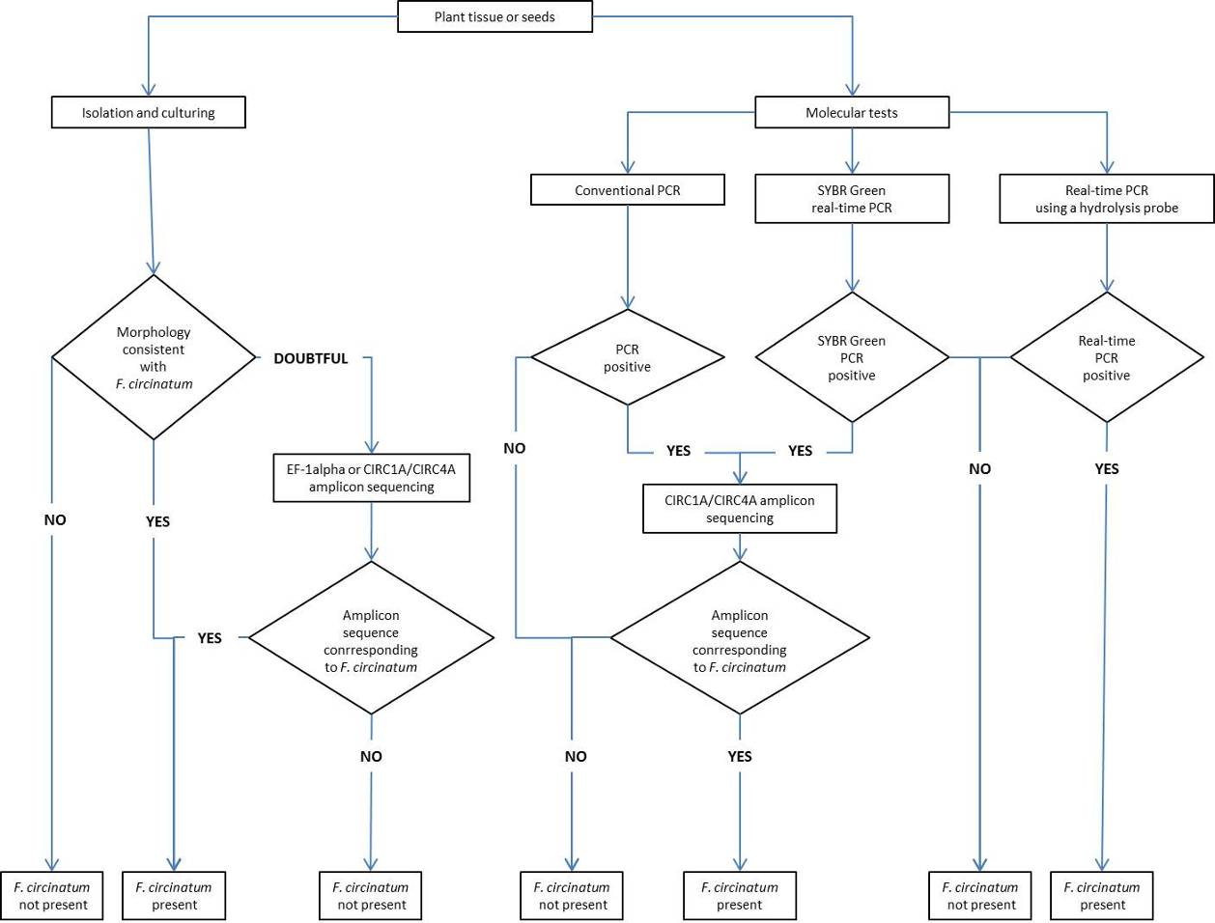
Figure 1. Flow diagram for the identification of Fusarium circinatum in a plant sample.
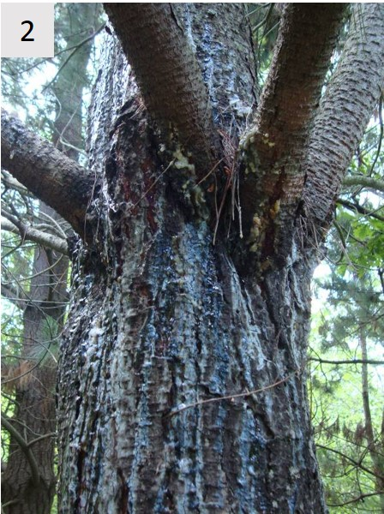 | 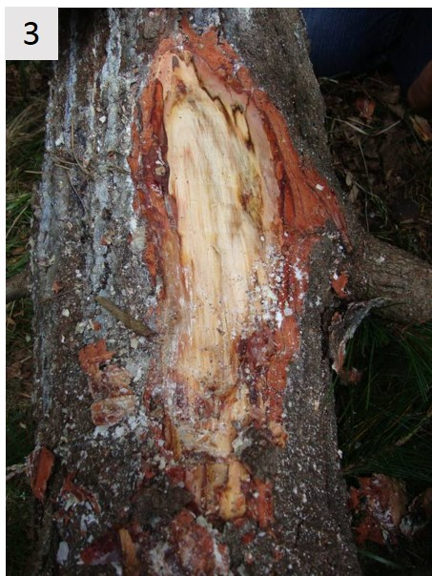
Figures 2, 3. 2: Canker on a Pinus radiata trunk caused by Fusarium circinatum associated with conspicuous and sometimes resinous exudates. 3: Removal of the bark on a Pinus radiata trunk shows subcortical lesions with brown and resin-impregnated tissues caused by Fusarium circinatum.
Photo courtesy A. Pérez-Sierra, Forest Research, United Kingdom.
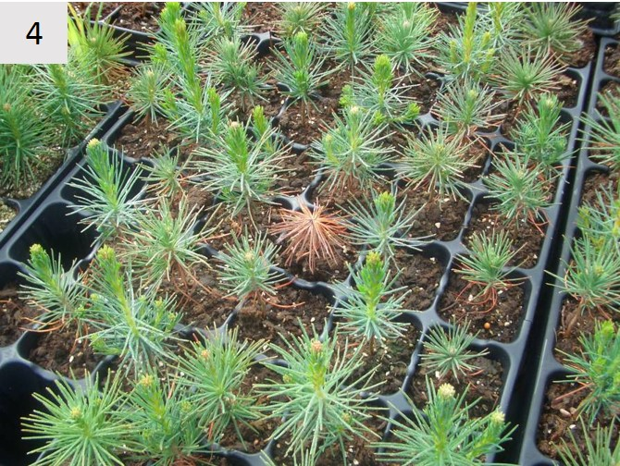 | 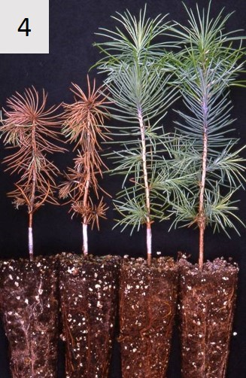
Figure 4. Typical symptoms of Fusarium circinatum on infected seedlings. Photos courtesy E. Landeras, Laboratorio de Sanidad Vegetal, Oviedo, Spain.
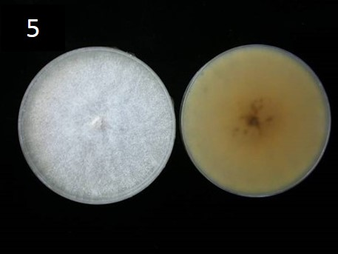
Figure 5. Colony morphology of Fusarium circinatum after 14 days on potato dextrose agar, and the reversed plate.
Photos courtesy M. Berbegal, Universidad Politécnica de Valencia, Spain and A. Pérez-Sierra, Forest Research, United Kingdom.
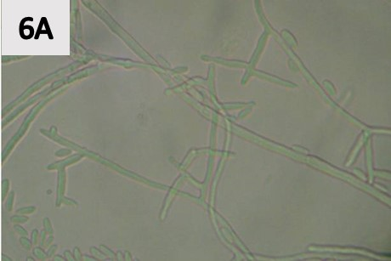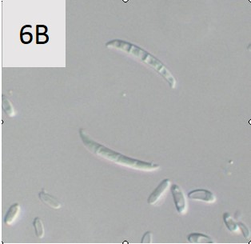
Figure 6. In vitro characteristics of Fusarium circinatum (×1 000): (A) Monophialidic and polyphialidic conidiophores and microconidia; and (B) Macroconidia and microconidia.
Photos courtesy A. Pérez-Sierra, Forest Research, United Kingdom.
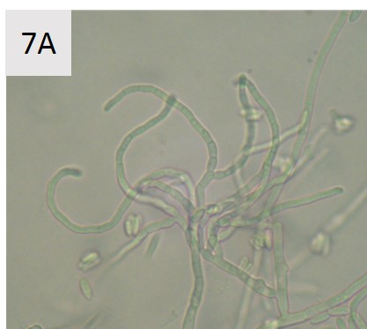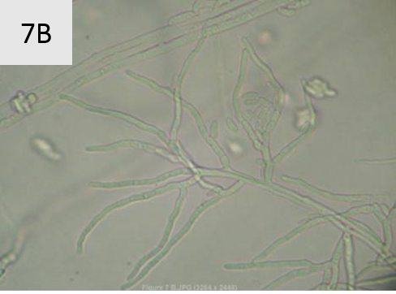
Figure 7. Sterile hyphae, characteristic of Fusarium circinatum: (A) coiled; and (B) not distinctively coiled
Photos courtesy A. Pérez-Sierra, Forest Research, United Kingdom.
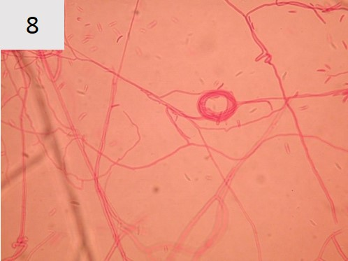
Figure 8. Commonly observed “spiral-wrapped” hyphae at the surface of the agar, which may be produced by several species of Fusarium.
Photo courtesy R. Ioos, ANSES, Malzéville, France.

In this diagnostic protocol, methods (including reference to brand names) are described as published, as these defined the original level of sensitivity, specificity and reproducibility achieved. The use of names of reagents, chemicals or equipment in these diagnostic protocols implies no approval of them to the exclusion of others that may also be suitable. Laboratory procedures presented in the protocols may be adjusted to the standards of individual laboratories, provided that they are adequately validated.
See footnote ¹

