[PleaseReview document review. Review title: 2016 Third consultation on Draft ISPM on International movement of wood. Document title: 2006-029_International_Movement_of_Wood_2016-05-28.docx]

[1]Draft ISPM: International movement of wood (2006-029)
[2]Status box
[3]This is not an official part of the standard and it will be modified by the IPPC Secretariat after adoption.
[4]Date of this document | [5]2016-05-09
[6]Document category | [7]Draft ISPM
[8]Current document stage | [9]2016-05 from Standards Committee (SC) to third consultation
[10]Major stages | [11]2007-03 CPM-2 (2007) added topic International movement of wood (2006-029) to work programme  [12]2007-11 Standards Committee (SC) approved draft specification for member consultation  [13]2007-12 Draft specification submitted to member consultation  [14]2008-05 SC approved Specification 46  [15]2008-12 Technical Panel on Forest Quarantine (TPFQ) drafted ISPM  [16]2009-07 TPFQ revised draft ISPM  [17]2010-04 SC revised draft ISPM  [18]2010-09 TPFQ revised draft ISPM  [19]2012-11 SC reviewed draft ISPM and requested SC members comments, sent to steward  [20]2013-05 SC reviewed, revised and approved draft ISPM for member consultation  [21]2013-07 Member consultation  [22]2014-02 Steward revised draft ISPM  [23]2014-05 SC-7 revised and approved draft ISPM for substantial concerns commenting period (SCCP)  [24]2014-06 SCCP  [25]2014-10 Steward revised draft ISPM after SCCP  [26]2014-11 SC revised and approved draft ISPM for CPM adoption  [27]2015-02 Formal objections received 14 days prior to CPM-10  [28]2015-05 SC reviewed formal objection  [29]2015-10 Steward revised draft ISPM with TPFQ  [30]2015-11 To SC for consideration of the formal objections received 14 days prior to CPM-10  [31]2015-12 Steward revised draft ISPM after SC comments  [32]2016-02 Steward revised draft ISPM with TPFQ and revised Appendix 1: Illustrations of bark and wood  [33]2016-05 SC approved draft ISPM for third consultation
[34]Steward history | [35]2006-05 SC Mr Greg WOLFF (CA, Lead Steward)  [36]2007-11 SC Mr Christer MAGNUSSON (NO, Assistant Steward)  [37]2009-11 SC Ms Marie-Claude FOREST (CA, Lead Steward)  [38]2009-11 SC Mr Greg WOLFF (CA, Assistant Steward)  [39]2013-05 SC Ms Marie-Claude FOREST (CA, Lead Steward)  [40]2013-05 SC Mr D.D.K. SHARMA (IN, Assistant Steward)  [41]2016-05 SC Mr Rajesh RAMARATHAM (CA, Lead Steward)
[42]Notes | [43]2014-11 Edited (AF/BL/RR)  [44]Revised definition of the Glossary term “wood (as a commodity class)” was adopted by CPM-11 (2016)

[45]CONTENTS
[46](To be inserted)

[47]INTRODUCTION

[48]Scope
[49]This standard provides guidance for the assessment of the pest risk of wood and describes phytosanitary measures which may be used to reduce the risk of introduction and spread of quarantine pests associated with the international movement of wood, in particular those that infest trees.
[50]This standard covers wood commodities such as: (1) round wood and sawn wood (with or without bark); and (2) materials from the mechanical processing of wood such as wood chips, sawdust, wood wool and wood residue (all with or without bark). This standard covers wood of gymnosperms and angiosperms (i.e. dicotyledons and some monocotyledons, such as palms) but not bamboo.
[51]Wood packaging material is covered within the scope of ISPM 15 (Regulation of wood packaging material in international trade) and therefore is not covered in this standard.
[52]Products manufactured from wood (such as furniture) and wooden handicrafts are not covered in this standard.
[53]Wood may also carry contaminating pests, however, they are not covered under this standard.

[54]References
[55]The present standard also refers to other International Standards for Phytosanitary Measures (ISPMs). ISPMs are available on the IPP at https://www.ippc.int/core-activities/standards-setting/ispms.
[56]CPM. 2008. Replacement or reduction of the use of methyl bromide as a phytosanitary measure. CPM Recommendation. In Report of the Third Session of the Commission on Phytosanitary Measures. Rome, 7–11 April 2008, Appendix 6. Rome, IPPC, FAO.
[57]FAO. 2009. Global review of forest pests and diseases. FAO Forestry Paper 156. Rome. 222 pp.

[58]Definitions
[59]Definitions of phytosanitary terms can be found in ISPM 5 (Glossary of phytosanitary terms).

[60]Outline of Requirements
[61]Pest risk varies among wood commodities such as round wood, sawn wood and wood material resulting from mechanical processing depending on the level of processing that the wood has undergone. This standard provides guidance on the pest risk associated with the wood commodities and the phytosanitary measures which may be applied to manage the pest risk.
[62]Pest risk analysis (PRA) undertaken by the national plant protection organization (NPPO) of the importing country should provide the technical justification for phytosanitary import requirements for quarantine pests associated with the international movement of wood.
[63]Options for phytosanitary measures for managing the pest risk related to wood, including bark removal, treatment, chipping and inspection are described in this standard.
[64]The NPPO of the importing country may require the removal of bark (to produce debarked or bark-free wood) as a phytosanitary import requirement.

[65]BACKGROUND
[66]Wood may carry pests that had infested trees from which the wood was produced. These pests may then infest trees in the PRA area. This is the pest risk primarily dealt with in this standard.
[67]Wood may also become infested after harvesting. The pest risk in such cases is for pests that infest harvested wood, rather than for pests infesting trees.
[68]Pests that have been shown historically to move with wood in international trade and establish in new areas include: insects that oviposit on bark (e.g. Lymantriidae), wood wasps, wood borers, wood-inhabiting nematodes, and certain fungi with dispersal stages that can be transported on wood. Therefore, wood (with or without bark) moved in international trade is a potential pathway for the introduction and spread of quarantine pests.
[69]Wood is commonly moved as round wood, sawn wood and mechanically processed wood. The pest risk presented by a wood commodity depends on a range of characteristics, such as the commodity’s type, the level of processing and the presence or absence of bark, and on factors such as the wood’s origin, the species, the intended use and any treatment applied to the wood.
[70]Wood is usually moved internationally to a specific destination and for a specific intended use. However, wood in trade is increasingly moved by intermediaries, whose practices of handling commodities may complicate the identification of its origin and intended use. Given the frequency of association between key pest groups and key wood commodities, it is important to provide guidance on phytosanitary measures. This standard provides guidance for effectively managing the risk of quarantine pests and for harmonizing the use of appropriate phytosanitary measures.
[71]The FAO publication Global review of forest pests and diseases (2009) provides information on some of the major forest pests of the world.
[72]To differentiate wood from bark as used in this standard, a drawing and photographs of a cross-section of round wood are provided in Appendix 1.

[73]IMPACT ON BIODIVERSITY AND THE ENVIRONMENT
[74]Implementation of this standard is considered to reduce significantly the likelihood of introduction and spread of quarantine pests thereby contributing to tree health and the protection of forest biodiversity. Certain treatments may have a negative impact on the environment and countries are encouraged to promote the use of phytosanitary measures that are environmentally acceptable.

[75]REQUIREMENTS

[76]1. Pest Risk Related to Wood Commodities
[77]The pest risk of the commodities addressed in this standard varies depending on the wood’s origin, species and characteristics, the level of processing or the treatment the wood has undergone, and the presence or absence of bark.
[78]This standard describes the general pest risk related to each wood commodity by indicating the major pest groups associated with it. Although the wood commodities described may be commonly infested with certain pest groups, the pest risk actually presented may depend on factors such as species, size, moisture content and intended use of the wood, and pest status at the origin and destination.
[79]Phytosanitary measures should not be required without appropriate technical justification based on PRA (as described in ISPM 2 (Framework for pest risk analysis) and ISPM 11 (Pest risk analysis for quarantine pests)), taking into account:
- [80]the pest status where the wood originated
- [81]the degree of processing before export
- [82]the ability of a pest to survive on or in the wood
- [83]the intended use of the wood
- [84]the likelihood of establishment of a pest in the PRA area, including the presence of a vector if needed for dispersal of the pest.
[85]Wood may be infested by pests present in the area of origin at the time of growing or harvesting. Several factors can influence a pest’s ability to infest trees or wood. These factors can also affect the ability of the pest to survive on or in the harvested wood. Such factors are: outbreaks of pests in the area of origin, forestry management practices, conditions during transportation and storage time, place and conditions and treatments applied to the wood once felled. These factors should be considered when evaluating the probability of introduction and spread of quarantine pests.
[86]In general, the greater the level of processing or treatment of the wood after harvest, the greater the reduction in pest risk. However, it should be noted that processing may change the nature of the pest risk. For example, chipping reduces the presence of certain insect pests but increases in surface area of the wood may facilitate its colonization by fungi. Pests that are associated with specific wood tissues (e.g. bark, outer sapwood) pose virtually no pest risk when the tissues that they inhabit are removed during processing. The pest risk associated with the removed material should be assessed separately if it is to be moved in trade as another commodity (e.g. cork, firewood, bark mulch).
[87]The pest groups identified in Table 1 and Table 2 are known to move with wood commodities and have shown the potential to establish in new areas.
[88]Table 1. Insect groups that may be associated with the international movement of wood
[89]Pest group | [90]Examples within the pest group
[91]Bark beetles | [92]Scolytinae, Molytinae
[93]Wood flies | [94]Pantophthalmidae
[95]Wood-boring beetles | [96]Anobiidae, Bostrichidae Cerambycidae, Curculionidae, Buprestidae, Oedemeridae
[97]Wood-boring moths | [98]Cossidae, Sesiidae Hepialidae
[99]Wood wasps | [100]Siricidae
[101]Termites and carpenter ants | [102]Rhinotermitidae, Kalotermidae, Formicidae
[103]Non-wood-boring moths | [104]Lymantriidae, Lasiocampidae
[105]Aphids and adelgids | [106]Adelgidae, Aphididae
[107]Scales | [108]Diaspididae
[109]Table 2. Groups of fungi and nematodes that may be associated with the international movement of wood
[110]Pest group | [111]Examples within the pest group
[112]Rust fungi | [113]Cronartiaceae, Pucciniaceae
[114]Pathogenic decay fungi | [115]Heterobasidion spp.
[116]Canker fungi | [117]Cryphonectriaceae
[118]Pathogenic stain fungi | [119]Ophiostomataceae
[120]Vascular wilt fungi | [121]Nectriaceae
[122]Nematodes | [123]Bursaphelenchus xylophilus, B. cocophilus
[124]There are some pest groups such as water moulds, bacteria, viruses and phytoplasmas known to be associated with wood which are unlikely to establish in new areas.

[125]1.1 Round wood
[126]Most round wood, with or without bark, is moved internationally for subsequent processing at destination. The wood may be sawn for use as construction material (e.g. as timber framing) or it may be used to produce wood materials (e.g. wood chips, bark chips, pulp, firewood, biofuels and manufactured wood products).
[127]Removing bark from round wood reduces the probability of introduction and spread of some quarantine pests. The level of reduction depends on the degree to which the bark and underlying wood have been removed and on the pest group. For example, complete bark removal (i.e. to produce bark-free wood) will greatly reduce the risk of infestation of most bark beetles in the wood. However, bark removal is unlikely to influence the incidence of deep wood borers, some species of fungi and wood-inhabiting nematodes.
[128]The pest risk of round wood is greatly influenced by the total amount of remaining bark on the debarked wood which in turn is greatly influenced by the shape of the round wood, the machinery used to remove the bark and to a lesser extent, by the species of tree. In particular, the widened areas at the base of a tree, especially where large root buttresses are present, and around branch nodes are preferred locations for beetle infestation and oviposition.
[129]Pest groups likely to be associated with round wood are listed in Table 3.
[130]Table 3. Pest groups likely to be associated with round wood
[131]Commodity | [132]Pest groups likely to be associated with round wood | [133]Pest groups less likely to be associated with round wood
[134]Round wood with bark | [135]Bark beetles, wood flies, wood-boring beetles, wood-boring moths, wood wasps, termites and carpenter ants, non-wood-boring moths, aphids and adelgids, scales, rust fungi, pathogenic decay fungi, canker fungi, pathogenic stain fungi, vascular wilt fungi, nematodes | [136]
[137]Round wood without bark | [138]Wood flies, wood-boring beetles, wood-boring moths, wood wasps, termites and carpenter ants, pathogenic decay fungi, canker fungi, pathogenic stain fungi, vascular wilt fungi, nematodes | [139]Bark beetles¹, non-wood-boring moths, aphids and adelgids, scales, rust fungi  [140]
[141]^{[Footnote 1]} Some bark beetles have life stages that are found in the wood below the surface of the bark and cambium and, therefore, may be present after debarking or complete bark removal.

[142]1.2 Sawn wood
[143]Most sawn wood, with or without bark, is moved internationally for use in building construction, in the manufacture of furniture, and for the production of wood packaging material, wood lathing, wood stickers, wood spacers, railway sleepers (ties) and other constructed wood products. Sawn wood may include fully squared pieces of wood without bark or partially squared wood with one or more curved edges that may or may not include bark. The thickness of the piece of sawn wood may affect the pest risk.
[144]Sawn wood from which some or all bark has been removed presents a much lower pest risk than sawn wood with bark. The pest risk of bark-related organisms is generally lower the smaller the bark piece remaining on the wood.
[145]The pest risk of bark-related organisms is also dependent on the moisture content of the wood. Wood from freshly harvested living trees has a high moisture content that decreases over time to ambient moisture conditions, which are less likely to allow bark-related organisms to survive. Further information on addressing pest risks through a combination of treatment and moisture reduction is provided in Appendix 2.
[146]Pest groups likely to be associated with sawn wood are listed in Table 4.
[147]Table 4. Pest groups likely to be associated with sawn wood
[148]Commodity | [149]Pest groups likely to be associated with sawn wood | [150]Pest groups less likely to be associated with sawn wood
[151]Sawn wood with bark | [152]Bark beetles, wood flies, wood-boring beetles, wood-boring moths, wood wasps, termites and carpenter ants, rust fungi, pathogenic decay fungi², canker fungi, pathogenic stain fungi, vascular wilt fungi, nematodes | [153]Non-wood-boring moths, aphids and adelgids, scales³
[154]Sawn wood without bark | [155]Wood flies, wood-boring beetles, wood-boring moths, wood wasps, termites and carpenter ants, pathogenic decay fungi², canker fungi, pathogenic stain fungi, vascular wilt fungi, nematodes | [156]Bark beetles, non-wood-boring moths, aphids and adelgids, scales³, rust fungi
[157]^{[Footnote 2]} Although pathogenic decay fungi may be present in sawn wood, most present a low pest risk because of the intended use of the wood and the limited potential for the fungi to produce spores on the wood.
[158]^{[Footnote 3]} Many species are removed during the squaring of wood, but remaining bark may present sufficient surface area for some species to survive after sawing.

[159]1.3 Wood materials produced from mechanical processing of wood (excluding sawing)
[160]Mechanical processes that reduce the size of wood pieces reduce the pest risk (e.g. wood chips) or render the wood pieces free from pests (e.g. sawdust, wood wool).

[161]1.3.1 Wood chips
[162]The pest risk of wood chips varies with their size and uniformity, and also with their method of storage. Pest risk is reduced when bark is removed and the chip size is below 3 cm in two dimensions (as described in Table 4 and section 2.3). The physical process of wood chipping is in itself lethal to some insect pests, particularly when a small chip size is produced. Chip size varies according to industry specifications and is usually related to the intended use of the chips (e.g. biofuel, paper production, horticulture, animal bedding, etc.). Some wood chips are produced in accordance with strict quality standards to minimize bark and fines (very small particles)
[163]Wood chipping also provides conditions conducive for certain insect survival. Some insects are attracted to the chemicals given off by cut wood and may therefore infest freshly cut wood chips.
[164]Depending on size, insect pests normally be found under the bark may be present in wood chips with bark. Many species of pathogenic decay fungi, canker fungi and nematodes may also be present in wood chips with or without bark. Spore dispersal of wood-inhabiting rust fungi would be very unlikely after the production of chips.

[165]1.3.2 Wood residue
[166]Wood residue is normally considered to present a high pest risk because it varies greatly in size and may or may not include bark. Wood residue is generally a waste by-product of wood being mechanically processed during production of a desired article; nevertheless, wood residue may be moved as a commodity.
[167]Pest groups likely to be associated with wood chips and wood residue are listed in Table 5.
[168]Table 5. Pest groups likely to be associated with wood chips and wood residue
[169]Commodity | [170]Pest groups likely to be associated with wood chips and wood residue | [171]Pest groups less likely to be associated with wood chips and wood residue
[172]Wood chips with bark and greater than 3 cm in two dimensions | [173]Bark beetles, wood flies, wood-boring beetles, wood-boring moths, wood wasps, termites and carpenter ants, rust fungi⁴, pathogenic decay fungi⁴, canker fungi, pathogenic stain fungi, vascular wilt fungi, nematodes | [174]Non-wood-boring moths, aphids and adelgids, scales
[175]Wood chips without bark and greater than 3 cm in two dimensions | [176]Wood flies, wood-boring beetles, wood-boring moths, wood wasps, termites and carpenter ants, pathogenic decay fungi⁴, canker fungi, pathogenic stain fungi, vascular wilt fungi, nematodes | [177]Bark beetles, non-wood-boring moths, aphids and adelgids, scales, rust fungi⁴
[178]Wood chips with bark and less than 3 cm in two dimensions | [179]Bark beetles, termites and carpenter ants, rust fungi⁴, pathogenic decay fungi⁴, canker fungi, pathogenic stain fungi, vascular wilt fungi, nematodes | [180]Wood-boring beetles, non-wood-boring moths, aphids and adelgids, scales, wood flies, wood-boring moths, wood wasps
[181]Wood chips without bark and less than 3 cm in two dimensions | [182]Termites and carpenter ants, pathogenic decay fungi⁴, canker fungi, pathogenic stain fungi, vascular wilt fungi, nematodes | [183]Bark beetles, non-wood-boring moths, aphids and adelgids, scales, wood flies, wood-boring beetles, wood-boring moths, wood wasps, rust fungi⁴
[184]Wood residue with or without bark | [185]Bark beetles, wood flies, wood-boring beetles, wood-boring moths, wood wasps, termites and carpenter ants, non-wood-boring moths, aphids and adelgids, scales, rust fungi⁴, pathogenic decay fungi⁴, canker fungi, pathogenic stain fungi, vascular wilt fungi, nematodes | [186]
[187]^{[Footnote 4]} Rust and pathogenic decay fungi may be present in consignments of wood chips or wood residue but are unlikely to present a risk for establishment or spread.

[188]1.3.3 Sawdust and wood wool
[189]Sawdust presents a lower pest risk. Only in certain cases may fungi and nematodes be associated with sawdust. Wood wool is considered to present a similar pest risk.

[190]2. Phytosanitary Measures
[191]The phytosanitary measures described in this standard should be required only if technically justified, based on PRA. Certain phytosanitary measures may be implemented to protect wood that has been produced in pest free areas but that may be at risk of subsequent infestation (e.g. during storage and transportation).
[192]The NPPO of the importing country may require limitations on the time frame for import. For example, the pest risk associated with round wood moved in trade may be managed by the NPPO specifying a certain time in which dispatch or import of a consignment may occur (e.g. during a time when a pest is inactive).
[193]The NPPO of the importing country may require and monitor the application of specific methods of processing, handling and appropriate disposal of waste that reduce the pest risk from the wood after import.
[194]The application of the phytosanitary measures listed below, may not prevent subsequent infestation by pests prior to dispatch., Various methods to prevent infestation after the application of a measure should be considered; for example, covering wood with tarpaulin for storage or using an enclosed conveyance.
[195]The NPPO of the exporting country or importing country should verify the application and the effectiveness of phytosanitary measures before export or at the point of entry, respectively, in accordance with ISPM 20 (Guidelines for a phytosanitary import regulatory system), ISPM 23 (Guidelines for inspection) and ISPM 31 (Methodologies for sampling of consignments).
[196]As many pests associated with wood are specific to particular tree species or genera, phytosanitary import requirements are often accordingly species or genus specific. Therefore, the NPPO of the exporting country should verify that the wood in the consignment complies with phytosanitary import requirements related to species or genus.
[197]The following are commonly used options for phytosanitary measures.

[198]2.1 Removal of bark
[199]Some quarantine pests are commonly found in or just beneath the bark. To reduce the pest risk, the NPPO of the importing country may require the removal of bark (to produce bark-free or debarked wood) as a phytosanitary import requirement and, in the case of debarked wood, the NPPO may set tolerance levels for remaining bark. Where bark remains with wood, treatments may be used to reduce the pest risk associated with bark.

[200]2.1.1 Bark-free wood
[201]The complete removal of bark from round wood and other wood commodities (i.e. to produce bark-free wood) physically removes a layer of material in which a large number of pests may develop, as well as eliminates large areas of uneven surface that provide concealment for other pests.
[202]Bark removal eliminates pests found mostly on the surface of bark such as aphids, adelgids, scale insects, and non-wood-boring moths in some life stages. Moreover, bark removal eliminates most bark beetles and also prevents post-harvest infestation by other wood pests such as wood wasps and large wood borers (e.g. Monochamus spp.).
[203]Where the NPPO of the importing country requires that wood be bark-free, the commodity should meet the definition of bark-free wood stated in ISPM 5 (see Appendix 1 for illustration of ingrown bark and bark pocket). In many cases, this wood may have evidence of cambium, which may appear as a brown discoloured tissue on the surface of the wood, but this should not be considered as the presence of bark and does not pose a risk for pests associated with bark. In general, verification of bark-free wood should simply confirm that there is no evidence of the layer of tissue above the cambium.

[204]2.1.2 Debarked wood
[205]The mechanical process used in the commercial removal of bark from wood does not usually result in the wood becoming bark-free.
[206]When wood is debarked, pieces of bark may remain. Depending on the number and size of pieces remaining, pests associated with the bark (e.g. bark beetles, aphids, adelgids, scales) may be completely or partly removed.
[207]Debarking to the tolerances prescribed below reduces the risk of bark beetles completing their life cycles in untreated wood.
[208]Any number of visually separate and clearly distinct small pieces of bark may remain, if they are:
- [209]- less than 3 cm in width (regardless of the length) or
- [210]- greater than 3 cm in width, with the total surface area of an individual piece of bark less than 50 cm2.
[211]When prescribed as a phytosanitary import requirement by the NPPO of the importing country, the NPPO of the exporting country should ensure that these requirements for debarked wood have been met.

[212]2.2 Treatments
[213]Some treatment types may not be effective against all pests. Further guidance on treatments which may be used to address the pest risks of wood is provided in Appendix 2.
[214]For all chemical treatments, the penetration depth and thus the efficacy varies with the application process (dosage, temperature, etc.), the presence or absence of bark on the wood, and the wood species and moisture content. The removal of bark often improves chemical treatment penetration and may reduce the incidence of infestation of treated wood.
[215]Treatments accepted internationally, as found as annexes to ISPM 28 (Phytosanitary treatments for regulated pests) may be prescribed as phytosanitary import requirements for the import of some wood commodities.
[216]Treatments should be applied under the supervision or authority of the NPPO of the exporting country to meet the phytosanitary import requirements. The NPPO of the exporting country should make arrangements to ensure that treatments are applied as prescribed and where appropriate should verify that wood is free of target pests by inspection or testing. Specific tools (e.g. electronic thermometers, gas chromatographs, moisture meters connected to recording equipment) may also be used to verify treatment application. Chemical pressure impregnation and chemical diffusion may leave specific colour stains on the surface of the wood.
[217]Regardless of the treatment applied, the presence of live quarantine pests should be considered as non-compliance of the consignment, with the exception of irradiation, which may result in an inactivated but live pest. In addition, the finding of suitable indicator organisms or fresh frass, indicating treatment failure, may also be deemed non-compliance.

[218]2.3 Chipping
[219]The mechanical action of chipping or grinding wood can be effective in destroying most wood-dwelling pests. Reducing the chip size to a maximum of 3 cm in at least two dimensions may be used to address most insect pest risks. However, fungi, nematodes and small insects such as some Scolytinae or small Buprestidae, Bostrichidae or Anobiidae may continue to present a pest risk.

[220]2.4 Inspection and testing
[221]Inspection or testing may be used for the detection of specific pests associated with wood. Depending on the wood commodity, inspection may be used to identify specific signs or symptoms of pests. For example, inspection may be used to detect the presence of bark beetles, wood borers and decay fungi on round wood and sawn wood. Inspection may also be carried out at various points along the production process to determine if measures applied have been effective.
[222]Where undertaken, inspection methods should enable the detection of any signs or symptoms of quarantine pests. The detection of certain other organisms may indicate treatment failure. Signs may include the fresh frass of insects, galleries or tunnels of wood borers, staining on the surface of the wood caused by fungi, and voids or signs of wood decay. Signs of wood decay include bleeding cankers, long discontinuous brown streaks on outer sapwood and outer sapwood discoloration, soft areas in the wood, unexplained swelling, resin flow on logs, and cracks, girdling and wounds in sawn wood. Where bark is present it may be peeled back to look for signs of insect feeding and galleries, and for staining or streaking of the wood underneath, which may indicate the presence of pests. Acoustic, sensory and other methods may also be used for detection. Further examination should be made to verify whether live quarantine pests or indicator organisms are present; for example, examination for living life stages of insects such as egg masses and pupae.
[223]Testing may be used to verify the application or effect of other phytosanitary measures such as the application of treatments. Testing is generally limited to the detection of fungi and nematodes. For example determination of the presence of nematodes that are quarantine pests may be made using a combination of microscopy and molecular techniques on samples of wood taken from consignments.
[224]Guidance on inspection and sampling is provided in ISPM 23 and ISPM 31.

[225]2.5 Pest free areas and pest free places of production
[226]Pest free areas (ISPM 4 (Requirements for the establishment of pest free areas); ISPM 8 (Determination of pest status in an area); ISPM 29 (Recognition of pest free areas and areas of low pest prevalence)) and pest free places of production (ISPM 10 (Requirements for the establishment of pest free places of production and pest free production sites)) may be established to manage the pest risk associated with wood. However, the use of pest free places of production may be limited to specific situations such as forest plantations located within agricultural or suburban areas.

[227]2.6 Areas of low pest prevalence
[228]Areas of low pest prevalence (ISPM 8; ISPM 22 (Requirements for the establishment of areas of low pest prevalence); ISPM 29) may be established to reduce the pest risk associated with the movement of wood. Biological control may be used as an option in achieving the requirements for an area of low pest prevalence.

[229]2.7 Systems approaches
[230]The pest risk of the international movement of wood may be managed effectively by developing systems approaches that integrate measures for pest risk management in a defined manner (ISPM 14 (The use of integrated measures in a systems approach for pest risk management)). Existing forest management systems, both pre- and post-harvest, including processing, storage and transportation may include activities such as site selection from pest free areas, inspection to ensure the wood is pest free, treatments and other measures which when integrated in a systems approach are effective in pest risk management.
[231]Some of the pest risk associated with round wood (in particular that of deep wood borers and certain nematodes) is difficult to manage through the application of a single phytosanitary measure. In these situations, a combination of phytosanitary measures in a systems approach may be applied.
[232]In accordance with ISPM 14, the NPPO of the importing country may agree with the NPPO of the exporting country to implement additional measures within its territory for transporting, storing or processing wood after import. For example, round wood with bark that may harbour bark beetles that are quarantine pests may be permitted to enter the importing country only during a period when the bark beetles are not active. Processing in the importing country to remove the pest risk would be required to occur before individuals develop to the active stage. Requirements that the wood be debarked and the bark or wood residue be used as a biofuel or otherwise destroyed before the active period of the beetles commences could be used to sufficiently prevent the risk of introduction and spread of the bark beetles that are quarantine pests.
[233]The pest risk associated with fungi may be managed effectively through the application of appropriate harvesting measures (e.g. visual selection of wood free from decay) and the application of a surface fungicide.

[234]3. Intended Use
[235]The intended use of wood may affect its pest risk, because some intended uses (e.g. round wood as firewood, wood chips as biofuel or for horticulture) may increase the probability of introduction and spread of quarantine pests (ISPM 32 (Categorization of commodities according to their pest risk)). Therefore, intended use should be taken into account when assessing or managing pest risk associated with the international movement of wood.

[236]4. Non-compliance
[237]Relevant information on non-compliance and emergency action is provided in ISPM 20 and ISPM 13 (Guidelines for the notification of non-compliance and emergency action). The NPPO of the importing country should notify the NPPO of the exporting country in cases where live quarantine pests are found. NPPOs are also encouraged to notify other relevant cases of non-compliance as specified in ISPM 13.
[238]
[239]This appendix is for reference purposes only and is not a prescriptive part of the standard.

[240]APPENDIX 1: Illustrations of bark and wood
[241]A drawing (Figure 1) and a photograph (Figure 2) of a cross-section of round wood and a photograph of sawn wood (Figure 3) are provided below to better differentiate wood and cambium from bark.
[242]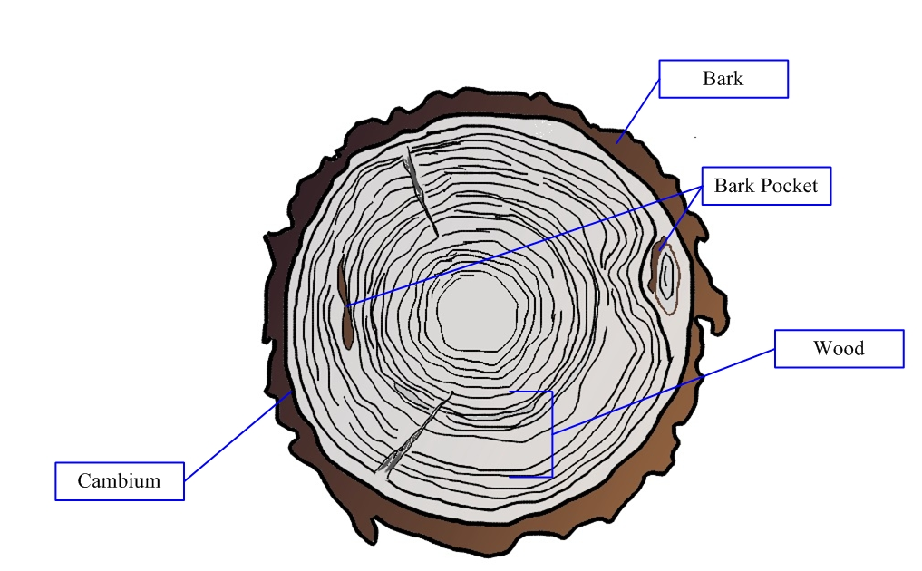
[243]Figure 1. Drawing of a cross-section of round wood. Drawing courtesy Shane Sela, Canadian Food Inspection Agency (2016).
[244]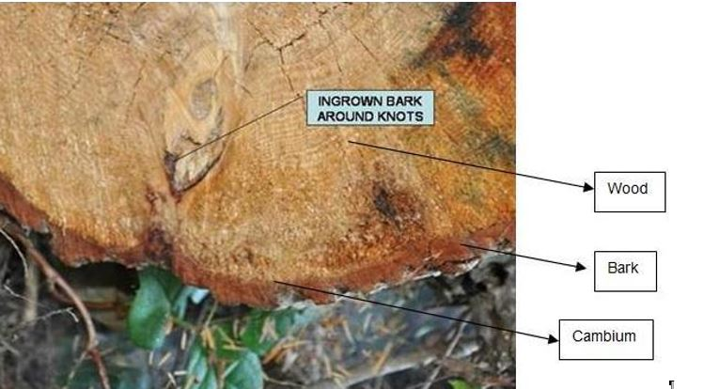
[245]Figure 2. Photograph of a cross-section of round wood. Photo courtesy Shane Sela, Canadian Food Inspection Agency (2014).
[246]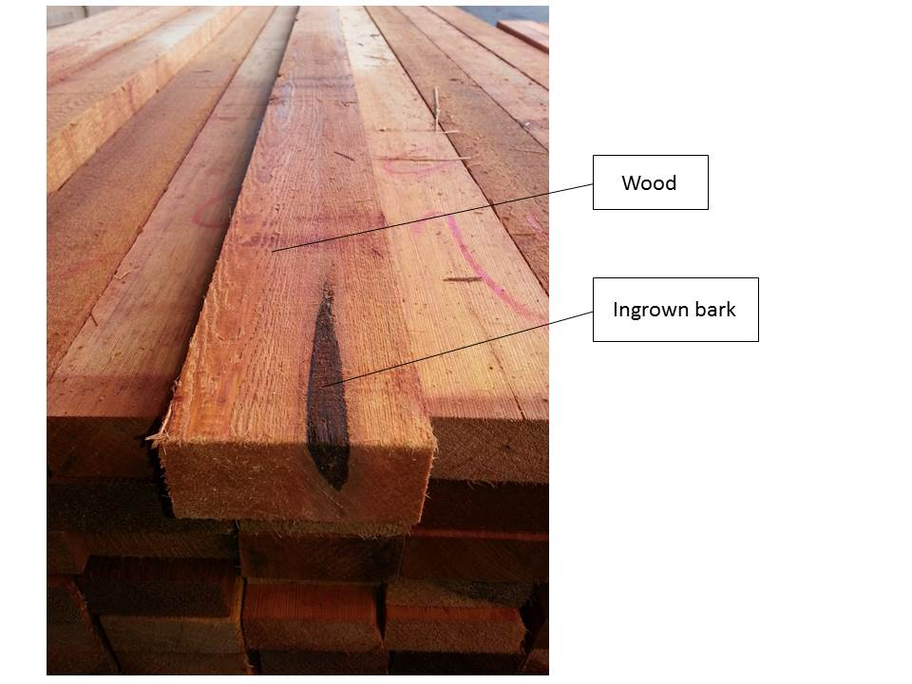
[247]Figure 3. Photograph of sawn wood. Photo courtesy Chuck Dentelbeck, Canadian Lumber Standards Accreditation Board (2014).

[248]APPENDIX 2: Treatments

[249]Fumigation
[250]Fumigation may be used in controlling pests associated with wood.
[251]Despite the proven effectiveness of some fumigants against certain pests, there are limitations to their use to reduce pest risk. Fumigants vary in their ability to penetrate the wood and some are therefore effective only against pests in, on or just beneath the bark. The penetration depth for some fumigants may be limited to about 10 cm from the wood surface. Penetration is greater in dry than in fresh-cut wood.
[252]For some fumigants, the removal of bark before fumigation may improve the efficacy of the treatment.
[253]Before selecting fumigation as a phytosanitary measure, NPPOs should take into account the CPM Recommendation Replacement or reduction of the use of methyl bromide as a phytosanitary measure (CPM, 2008).

[254]Spraying or dipping
[255]Spraying with or dipping in chemicals may be used in controlling pests associated with wood, excluding wood chips, sawdust, wood wool, bark and wood residue.
[256]In the process of spraying or dipping, liquid or dissolved chemicals are applied to wood at ambient pressure. This treatment results in limited penetration into the sapwood. Penetration depends on the species of the wood, the kind of wood (sapwood or heartwood), and the properties of the chemical product. Both removal of bark and application of heat increase the depth of penetration into the sapwood. The active ingredient of the chemical product may not prevent the emergence of pests already infesting the wood. Protection of the treated wood from subsequent pest infestation depends on the protective layer of chemical product remaining intact. Post-treatment infestation by some pests (e.g. dry wood borers) may take place if the wood is further sawn after treatment and a portion of the cross-section has not been penetrated by the chemical product.

[257]Chemical pressure impregnation
[258]Chemical pressure impregnation may be used in controlling pests associated with wood, excluding wood chips, sawdust, wood wool, bark and wood residue.
[259]The application of a preservative using vacuum, pressure or thermal processes results in a chemical product applied to the surface of the wood being forced deep into that wood.
[260]Chemical pressure impregnation is commonly used to protect wood from infestation by pests after other treatments. It may also have some effect in preventing the emergence to the wood surface of pests that have survived treatment. The penetration of the chemical product into the wood is much greater than with spraying or dipping, but depends on the wood species and the properties of the chemical product. Penetration is generally throughout the sapwood and through a limited portion of the heartwood. Debarking or mechanical perforation of the wood may improve penetration of the chemical product. Penetration also depends on the moisture content of the wood. Drying wood before chemical pressure impregnation may also improve penetration. Chemical pressure impregnation is effective against some wood-boring insects. In some impregnation processes, the chemical is applied at a temperature sufficiently high to be equivalent to a heat treatment. The protection of the treated wood from subsequent infestation depends on the protective layer of the chemical product remaining intact. Post-treatment infestation by some pests (e.g. dry wood borers) may take place if the wood is sawn after treatment and a portion of the cross-section has not been penetrated by the chemical product.

[261]Heat treatment
[262]Heat treatment may be used in controlling pests associated with all wood commodities. The presence or absence of bark has no effect on the efficacy of heat treatment but should be taken into account if a heat treatment schedule specifies the maximum dimensions of the wood being treated.
[263]The process of heat treatment involves heating wood to a temperature for a period of time (with or without moisture reduction) that is specific to the target pest. The minimum treatment time in the heat chamber necessary to reach the required temperature throughout the profile of the wood depends on the wood’s dimensions, species, density and moisture content as well as on the capacity of the chamber and other factors. The heat may be produced in a conventional heat treatment chamber or by dielectric, solar or other means of heating.
[264]The temperature required to kill pests associated with wood varies because heat tolerance varies across species. Heat-treated wood may still be susceptible to common moulds, particularly if moisture content remains high; however, mould should not be considered a phytosanitary concern.

[265]Kiln-drying
[266]Kiln-drying may be used for sawn wood and many other wood commodities.
[267]Kiln-drying is a process in which the moisture content in wood is reduced, by the application of heat, to achieve the prescribed moisture content for the intended use of the wood. Kiln-drying may be considered a heat treatment if carried out at sufficient temperatures and for sufficient durations. If lethal temperatures are not achieved throughout the relevant wood layers, kiln-drying on its own should not be considered a phytosanitary treatment.
[268]Some species in the pest groups associated with wood commodities are dependent on moisture and therefore may be inactivated during kiln-drying. Kiln-drying also permanently alters the physical structure of the wood, which prevents subsequent resorption of sufficient moisture to sustain existing pests and reduces the incidence of post-harvest infestation. However, individuals of some species may be capable of completing their life cycles in the new environment of reduced moisture content. If favourable moisture conditions are re-established, many fungi and nematodes and some insect species may be capable of continuing their life cycles or infesting the wood after treatment.

[269]Air-drying
[270]Compared with kiln-drying, air-drying reduces wood moisture content only to ambient moisture levels and is therefore less effective against a broad range of pests. The pest risk remaining after treatment depends on the duration of drying and the moisture content and on the intended use of the wood. Moisture reduction through air-drying alone should not be considered a phytosanitary measure.
[271]Although moisture reduction through air-drying or kiln-drying alone may not be a phytosanitary measure, wood dried to below the fibre saturation point may be unsuitable for infestation by many pests. Therefore the likelihood of infestation of dried wood is very low for many pests.

[272]Irradiation
[273]The exposure of wood to ionizing radiation (e.g. accelerated electrons, x-rays, gamma rays) may be sufficient to kill, sterilize or inactivate pests (ISPM 18 (Guidelines for the use of irradiation as a phytosanitary measure)).

[274]Modified atmosphere treatment
[275]Modified atmosphere treatments may be applied to round wood, sawn wood, wood chips and bark.
[276]In such treatments, wood is be exposed to modified atmospheres (e.g. low oxygen, high carbon dioxide) for extended periods of time to kill or inactivate pests. Modified atmospheres can be artificially generated in gas chambers or allowed to occur naturally, for instance during water storage or when the wood is wrapped in airtight plastic.

[277]Potential implementation issues
[278]This section is not part of the standard. The Standards Committee in May 2016 requested the secretariat to gather information on any potential implementation issues related to this draft, please provide details and proposals on how to address these potential implementation issues.

